

It’s only the fourth week of the academic year, and already Bruce is asserting its dominance in the arts, with a place in the Grand Final of debating! Furthermore there will be sports throughout the week, and while we aren’t quite dominant, everyone is playing well, and it would be great to see as many of you as possible down at these events.

*Doing it for Bill since 2014*

THE BRUCE BILLITIN

**ISSUE 03: Monday 29th February- Sunday 6th March**

*Doing it for Bill since 2014*

THE MANY WONDERS OF CANBERRA

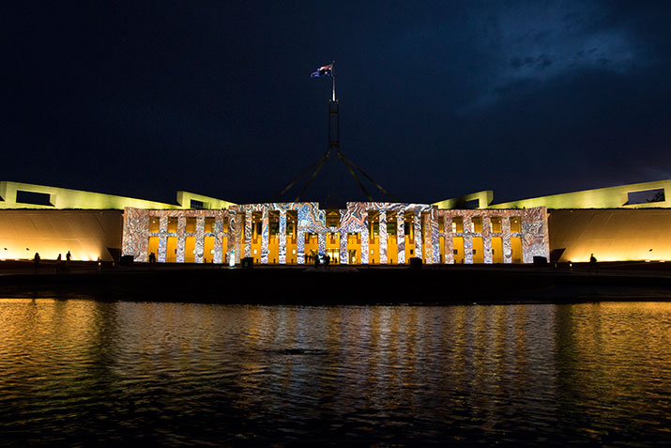

Enlighten 2016. Where you can see prominent prime- minister's.... projections.

Canberra, the home of the weird, wonderful, a place where artists can say anything is art, and likely get away with it. Make the most of our quirky capital this week with the following events:

* **Enlighten 2016** **(various venues until the 12th of March)**: Continuing throughout the week are the various performances, foodie delights and art which comprise Enlighten. Head to it’s website to find out more.
* **Lights**! **Canberra! Action! 11th of March at   
  the Senate Gardens:** Named by someone with a very poor sense of humor, this is a great event to pop down to view shortfilms and spend a relaxed Friday evening.
* **Canberra Balloon Spectacular 12th March**

BRUCE HALL: The OGM 7pm Monday in the JCR

Just your resident Salty Secretary here, with a bit of a brief outline of the OGM, which most electoral hopefuls seem to have forgotten about!

We need 75 people for the meeting to go ahead, so please make sure as many of you as possible make it up. Please arrive 10 minutes beforehand, as the meeting will start at 7pm on the dot.

First up will be the reports, followed by the

All the candidates will be giving a speech as called to by the Chair, and each speech shall last for 2 minutes. Please give all your respect to the speakers, and do not talk while someone is talking at the meeting.

The voting will be done online and will be organised by our brilliant returning officer Lachie Matthews.

So come up to the JCR on Monday night, try to engage with the discussions, and hopefully there will be no one to make this meeting longer than Leo’s wait for an Oscar!

SCHIMDT HAPPENS- What’s on in ANU

ANU remains quiet again this weekend (surprise surprise), but there are a few key events on which may be useful to those looking for a bit of a global touch to their degree.

* **ANU Global Programs Fair**: 11am to 3pm in Union Court. If you’ve ever thought about studying abroad as part of your degree, this fair is the perfect place to begin your search.
* **ANU ILS Law Career Networking Evening**: 7pm ANU college of law Foyer, follow in the footsteps of Sam Taylor and do some networking!

There are also loads of public lectures throughout the week on and around the place, all of which can be found at www.anu.edu.au/events

*All the world’s a stage, and all the men and women merely players* – Bill Shakespeare



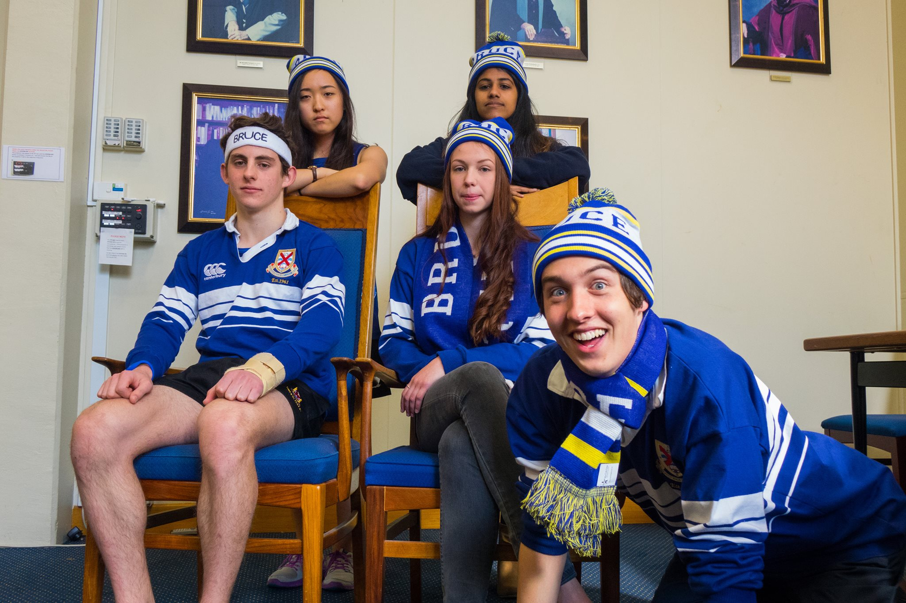

REPRESENTING THE DRAGON

MASCOT MATINCA’S GUIDE   
TO BRUCE PRIDE

Bruce Hall is love. Bruce Hall is life. And when you’re not only the interhall spelling bee champion (ask me how to spell altercation, or anything, just do it) but also the interhall mascot race champion, this is one thing you are qualified to talk about.

Here is my five step sequence to showing Bruce Pride

1. **Wear it with Pride**: Whether it be a dragon suit, a paper sign saying Yay Bruce, or even some trendy blue paint, you’ve got to wear it to share it.
2. **Go to an event**: There’s no point sitting in your room being proud, you’ve got to get out there and be loud
3. **Say it**: When I’m down at an event I like to hide my lanky awesomeness behind the suit, but you guys don’t need to, just yell whatever chant comes to your mind, or simply rhyme their name with the most random thing possible, e.g. Guthridge, Guthridge, cooler than a bar fridge (credit: Tarlinga + Lachie)
4. **Respect your opponents:** Did I taunt those Burgrats for their failure to spell articulate? Did I flaunt my superior mascot dynamics to all those other race hopefuls? Maybe a little…. But do as I say, not as I do, and try to show your opponents the respect they (might) deserve as if they too were at Bruce.
5. **Shake it off:** I find it always helps to dance a little to show your pride. For tips on correct dancing etiquette, refer to my tasty little number in the Bruce Hall leadership team video (table not required).

So there you have it, a simple yet effective guide on the best way to show off your pride. For more tasty tips and treats, you can find me in the buttery, playing them indie beats which you’ve likely never heard of, so come join me, but just don’t ask me where your late meal is….

**Arts:**

WE’RE IN A GRAND FINAL EVERYONE. BRUCE IS IN A GRAND FINAL. And you know what that means? That means we need absolutely everyone there.

**7pm Physics Lecture Theatre Wednesday the 9th March.**

**Sports**

* Basketball game times will be posted shortly.
* Tennis this next weekend, once again stay posted for game times.

GSA Announcement



* **International Women’s Day Panel Discussion and Lunch Tuesday 8th March:** What is sure to be an interesting discussion in the Arts centre, sign up on Eventbrite if you are interested.
* **Pamela Denoon Lecture Tuesday 8th March:** An inaugural lecture started in 1989 in memory of Pamela Denoon. This lecture aims to inspire and motivate women to find out more about issues for women in Australia, and is sure to be a good one for anyone interested in women’s rights.

TRIVIA

1. To the nearest Billion, what is Donald Trump’s estimated net 6. The Richter Scale is used to measure what?   
worth? 7. What is the name of the book which coined the term

2. What country invaded England in 1588? Catch-22, to describe a paradoxical situation?

3. Which Class A drug was once used in Toothache drops? 8. What was Oscar Wilde’s only novel?

4. What is the capital of Lichtenstein? 9. Who is the current top scorer in the EPL?

5. What architect designed the layout of Canberra? 10. Keith Urban is married to which Australian actress?

1. 5 Billion USD, 2. Spain, 3. Cocaine, 4. Vaduz, 5. Walter Burley Griffin, 6. Eathquake magnitude, 7. Catch-22, 8. The Picture of Dorian Gray, 9. Jamie Vardy, 10. Nicole Kidman